Matthew Tran
Thread Synchronization Lab: Mutexes and Race Conditions
In this lab, I explored thread synchronization in C using POSIX threads (pthread). I learned how race conditions occur when multiple threads access shared data without coordination, and how to prevent them using mutex locks.
Tools Used
- C programming language
- POSIX Threads (pthread)
- gcc compiler
- Linux terminal

Skills Learned
- Creating and managing multiple threads using pthread_create and pthread_join
- Identifying and reproducing race conditions in concurrent programs
- Using mutex locks (pthread_mutex_t) to synchronize thread access to shared data
- Comparing execution times and results with and without synchronization
- Observing how loop size and thread timing affect race condition visibility
- Implementing thread-safe code to ensure data consistency in multithreaded applications
- Understanding the trade-offs between synchronization overhead and program correctness

Task 1) Single-Thread Counting
I created a single thread to perform 600,000,000 additions to a shared variable sum. The main thread waited for the counting thread to finish using pthread_join.
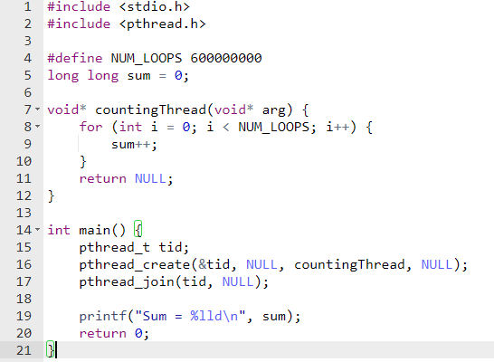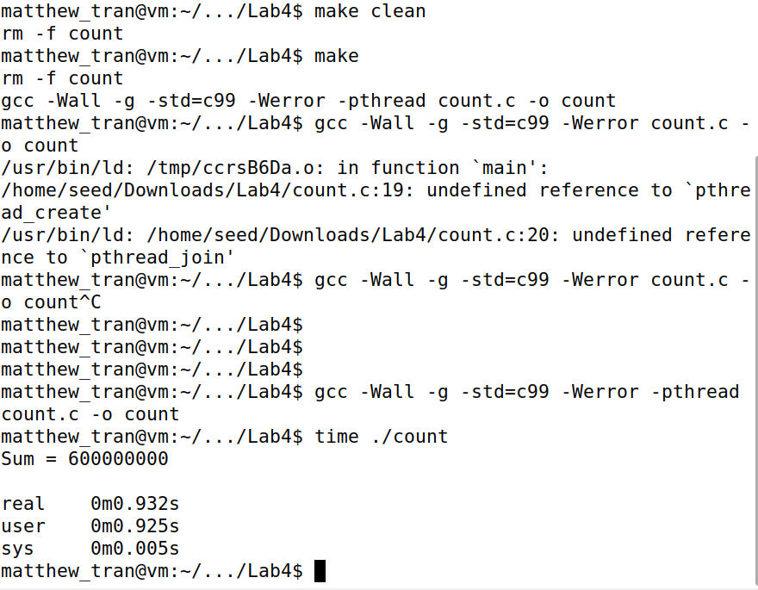
The thread function countingThread runs a loop incrementing sum. With a single thread, I observed consistent and correct results. No race condition occurred because only one thread accessed the shared variable.
Task 2) Two Threads Without Synchronization
I created two threads, each incrementing sum 300,000,000 times, without any synchronization mechanism.
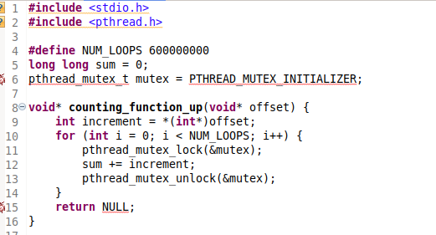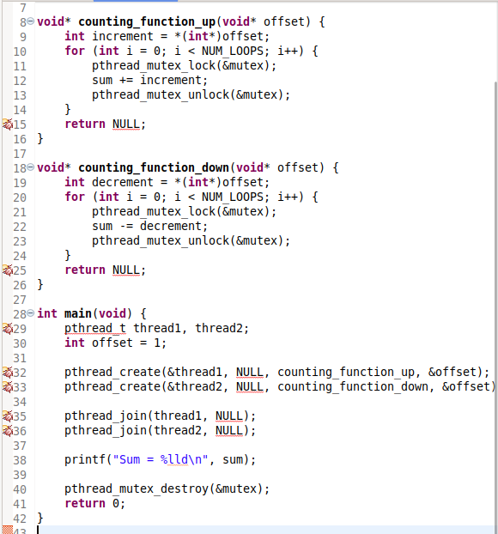
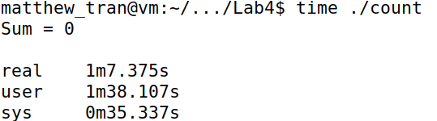
Since both threads modify the shared variable without any form of synchronization/teamwork, the situation is like a is a race. This task shows that when multiple threads access a shared resource without locks, the outcome can be unpredictable, depending on the timing of thread execution.

Task 3) Two Coinciding Threads (Separate Functions)
I launched two threads at nearly the same time, each running a separate counting function.
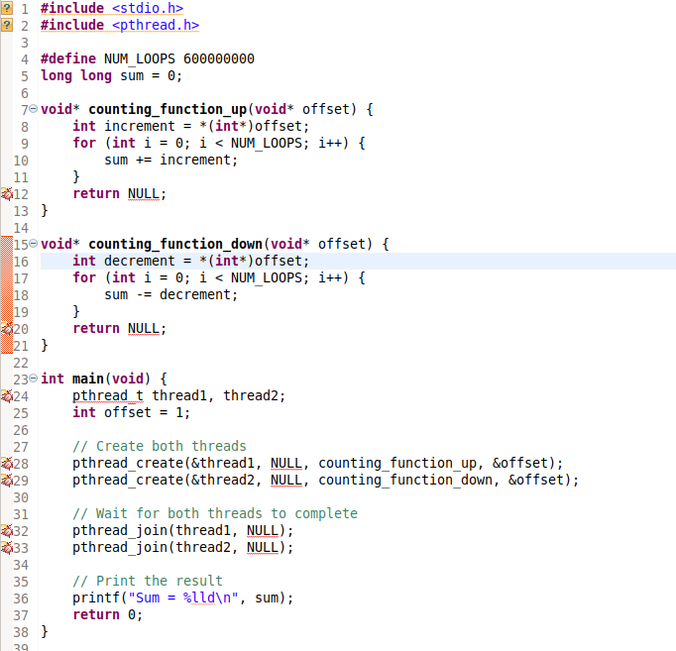
Show all screenshots and the screenshot for the time elapsed.
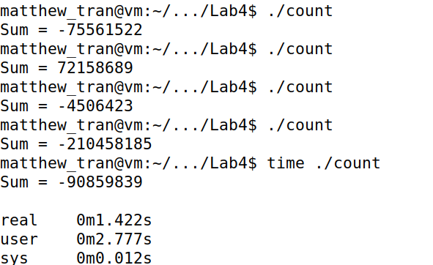
This task further highlights that starting threads at the same time without synchronization mechanisms does not prevent race conditions. The inconsistency shows the need for mutexes or other synchronization tools.

Task 4) Solving the Race Condition
I introduced a pthread_mutex_t lock. Each thread locks the mutex before updating sum and unlocks after.
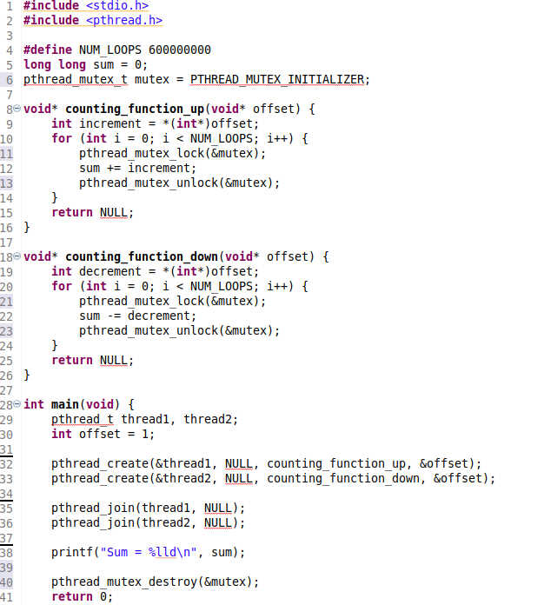
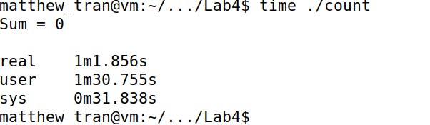
This task illustrates how mutexes can be used to prevent race conditions by controlling access to shared resources. Using pthread_mutex ensures that one thread completes its operation on sum before the other can access it, thus maintaining data integrity.
Task 5) Reduced Loop Count (20,000,000)
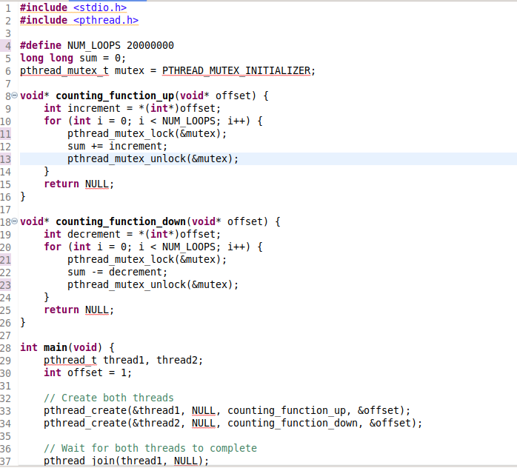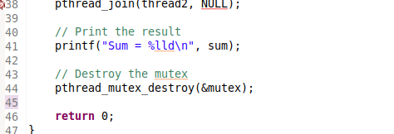
This demonstrates that reducing the number of operations can lead to faster execution times, as expected. However, the importance of mutexes remains, which does not matter the number of iterations, to maintain accuracy in multithreaded environments.

Task 6) Race Condition with Same Offset
Purpose: The purpose of this task is to see what happens when the same offset is passed in two different threads.
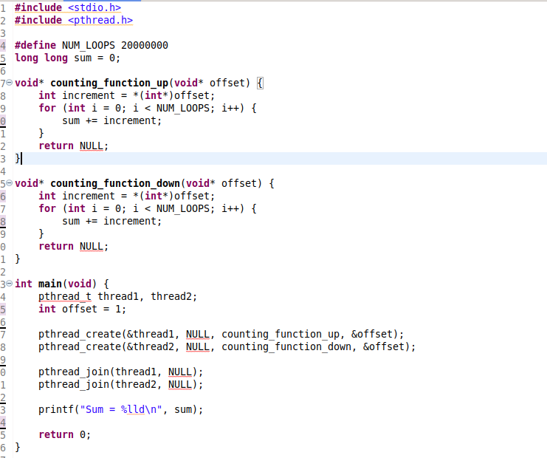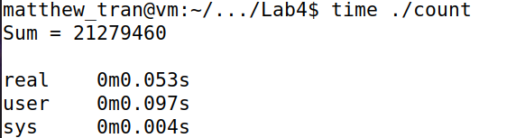
The task shows that even when threads are performing the same operation with the same offset, race conditions can lead to unreliable results. It shows the dangers of same time access to shared data without proper synchronization.

Task 7) Fixing with Mutex (Same Offset)
I added a mutex to Task 6’s code.
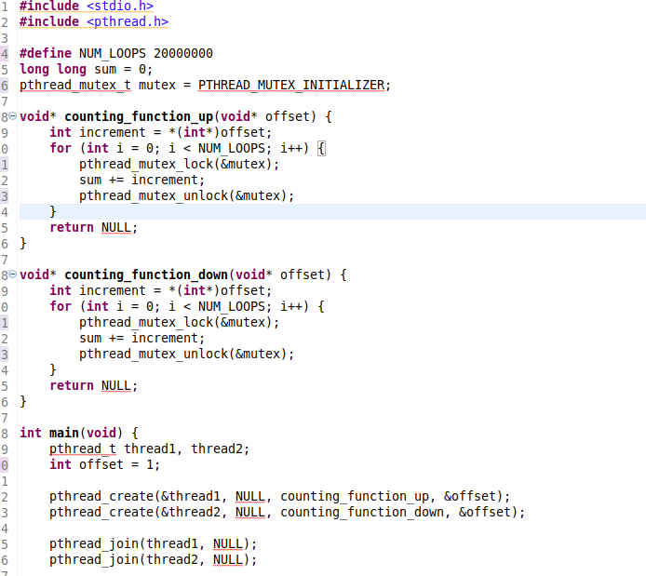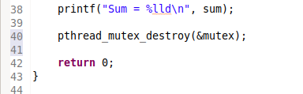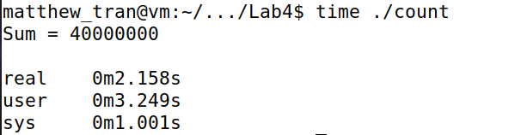
This task shows the importance of mutexes when multiple threads access shared data. Mutexes help achieve expectable outcomes by preventing concurrent access to critical sections.
Task 8) Small Loop Count Without Mutex
I reduced loops to a very small number (1000) and ran without a mutex.

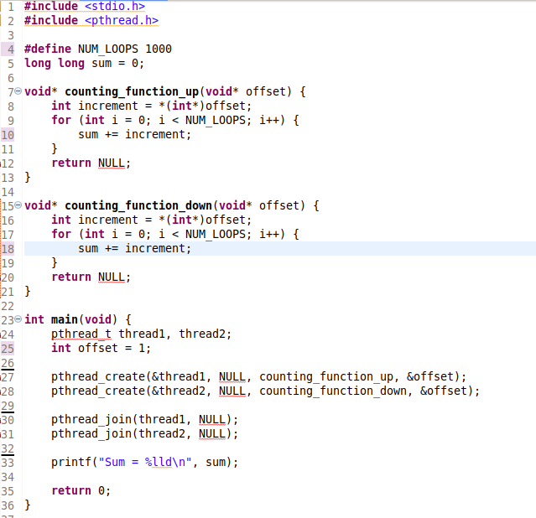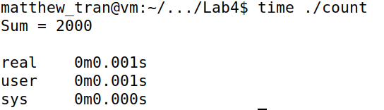
This task demonstrates that even with fewer iterations, mutexes are essential to ensure accuracy. However, it also shows that in low-iteration scenarios, the performance of mutexes may be less noticeable.

